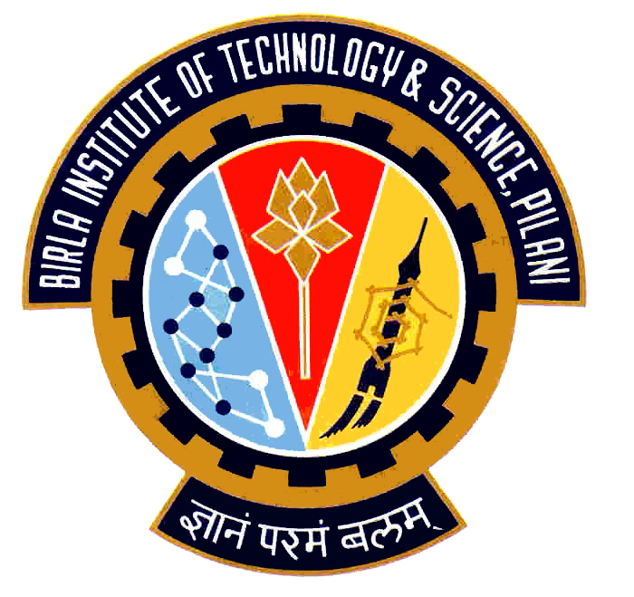

Election Commission

Birla Institute of Technology & Science – Pilani, Goa Campus, Zuarinagar, Goa-403726, INDIA
Tel: (0)98233 6368 Fax:0832-2557033

Final List of Candidates for Hostel Representatives:

CH 4
CULTURAL
N. MOUNIKA | 2007P8PS174
PATIL AMRITA ARUN | 2007P3PS004
MEGHA RASTOGI | 2007S3P8402
HOSTEL AND CAMPUS MANAGEMENT
SAMHITA BANDHOPADHYAY | 2007P7PS016
SNEHA NANDAN | 2007P4PS382
M. RACHANA REDDY | 2006S3P4615
MESS
V. SAI SUJAYA | 2006P1PS213
M. ALEKHYA | 2007P8PS269
SPORTS
M. SRI NAGA SMRITI | 2006S3P4467

Chief Warden CEC

